import numpy as np

import matplotlib.pyplot as plt

from skimage import io

im = io.imread('../input/cnn-data-sources/Mara.jpeg')

im.shape

800,600,3 (imagen de 800 x 600) a color, 3

plt.imshow(im)

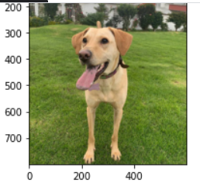

Separando canales de color

r = im[:,:,0]

g = im[:,:,1]

b = im[:,:,2]

plt.imshow(r.T,cmap='gray')

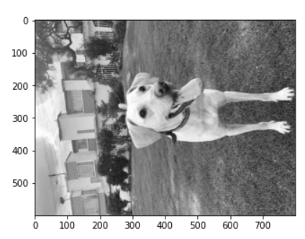

RGB con un único canal activo

r.shape

aux_dim = np.zeros([800,600])

red = np.dstack((r,aux_dim, aux_dim)).astype(np.uint8)

green = np.dstack((aux_dim, g, aux_dim)).astype(np.uint8)

blue = np.dstack((aux_dim, aux_dim,b)).astype(np.uint8)

plt.imshow(blue)

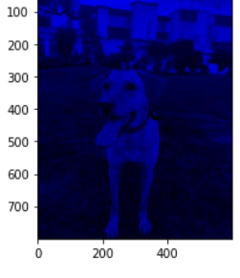

all_channels = np.concatenate((red, green, blue), axis=1)

plt.imshow(all_channels)

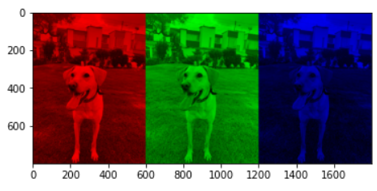

Otros cambios y modificaciones a imágenes

im_neg_pos = 255 - im

im32 = (im//32) * 32

im128 = (im//128) * 128

plt.imshow(im128)

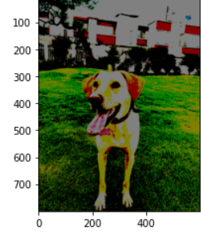

plt.imshow(im[270:530,150:400])

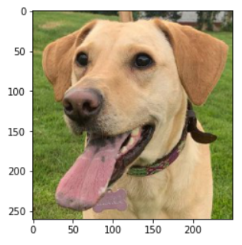

plt.imshow(np.concatenate((im , im_neg_pos, im32, im128), axis=1))

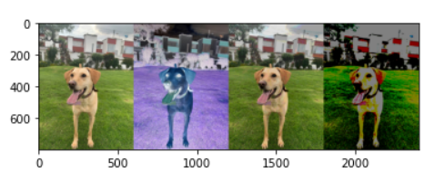

MAS GRANDE

plt.imshow(im[300:400,180:400,:])